Respected or Ruptured Planet Earth? | Reflections - Earth’s Destiny  Who Owns Planet Earth  What is Our Collective Priority? | Superpower Decline  Middle Power Ascent?
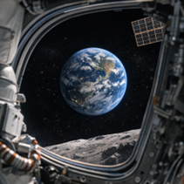 | Following 2000 years of trial and error trying to implement a fair planet earth governance system, so far, our ‘civilised world’ has completely failed.  Resolving ownership issues on territory, minerals, energy and power is the key question and is, as yet, unanswered. | 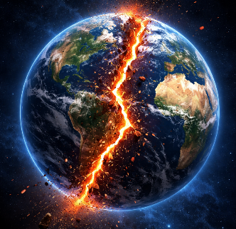
Any comprehensive Planet Earth Governance Plan, if it could ever be agreed, would require a period over at least 75 years to implement. It would require key adjustment opportunities to occur during this time scale, to ensure a prosperous and thriving Solar System gets a proper opportunity to fully develop.
Century 21 could be mankind’s next game changer, but does such a comprehensive plan currently exist?
Corrupt politicians, 3 dominant superpowers, new technologies have combined with decisions made by earlier corporations (specifically the oil sector) and the recent rise of Big Tech giants make it very unlikely.
Collectively, they have effectively wiped-out almost all every UN gains achieved since 1945. Resolving future ownership issues is vital. Answers as to how it could be achieved, very much focuses on the reader.
- The top 3 leaders of the Superpower nations. These players, individually and collectively, wield sufficient, political power, energy resources and military capability which includes the threat of launching intercontinental nuclear weapons. Planet earth is simply being held to ransom by them.
- 8 billion people living on the planet, can only pray for the increased freedom that enables them to own sufficient democratic power to participate and equally benefit on Earth’s continued wellbeing.
A prosperous Solar System, where everyone achieves millionaire status, is their dream come true.
Which group will ultimately gain sufficient power to save or destroy our precious planet? Is it
- Decision’s taken by selected individuals based on individual power, wealth and privilege?
- Collective agreements reached by at least 70 out every 100 of all the planet’s total population.
Sir David Attenborough’s recent Timelapse to the Future of Earth documentary, released in April 2026, clearly identified the previous 5 game-changing events that shaped Planet Earth over the last four plus billion years. Is the next potential game changer now too close to call? His continued role will be vital.
So, how bad are things right now? Check out this podcast example from a business guru (May 2026).
https://www.youtube.com/watch?v=ntsLaKf1XvE – Warren Buffett at UN - Trump rebuttal
Superpowers will always be unwilling to relinquish any of their existing powers and will fight hard to retain it. USA tactics to bully Canada, combined with its war with Iran has significantly damaged their international prestige, likewise with Russia’s war in Ukraine. Colossal change opportunities now exist.
It is likely that a group of ‘Middle Power’ UN members with EU support, will step up to replace the current vacuum that now exists, heralding a new ethos of democratic leadership style, including a Planet Earth Charter for Century 21 as indicated overleaf (A4 one page – summary only).
Proposed Planet Earth Charter for 21st Century
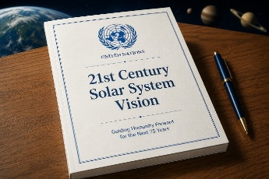 | Ten Visionary Rules  One Planet.  One Shared Responsibility.  One Future for Humanity.
🌍 1. Sovereign Nations
Every country remains free to choose its own governance and cultural path. No sovereignty interference.
📱 2. UN Re-Energised to focus on the development of One Planet, One Nation Thinking
The top leader of the United Nations chosen ‘Vatican style’ - 193 inputs helped by smartphone processes.
🌱 3. Planetary Responsibility
Major global decisions by individual countries must consider its long-term impact on Earth – UN monitored
🏗 4. Global Infrastructure
International cooperation to build major global projects to benefit ALL humanity – UN Monitored.
📊 5. Transparent Contribution
Countries and corporations get ranked for contributions made to planetary wellbeing across the planet.
🚀 6. Solar System Governance
Space resources treated as a shared heritage, belonging equally to each and every human inhabitant.
💡 7. Innovation for Humanity
Private innovation ideas positively encouraged and financed, if it clearly contributes to global progress.
🤖 8. Technology with Responsibility
Legal frameworks for AI, robotics, and future Universal Basic Income schemes are decided by the UN.
🏥 9. Universal Foundations
Global standards for healthcare, education, transportation, and equal human opportunity firmly established.
⚖ 10. Justice and Collective Security
UN Legislation will empower Courts system to resolve disputes between countries and big tech conflicts.
Moratorium – for next 10 years, all nuclear weapons are collectively stored at one location – South Pole.
Superpowers able to maintain their own equipment and inspect and monitor actions taken by others.
This Ten Point Charter was not created by rich, influential or powerful people, just one ordinary person. To progress this idea further, volunteers from each of the 193 UN countries are needed. The immediate aim – to publish an eBook, in every language (ChatGPT) for Xmas 2026. If this idea resonates, please forward to anyone you think could help or forward to others who could secure additional media coverage. Thank you.
Ian Linnegan ianlinnegan@icloud.com blog www.smartphone-democracy.com

